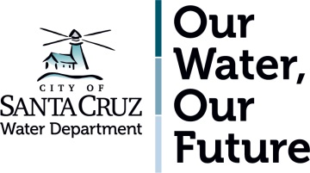

CITY OF SANTA CRUZ WATER DEPARTMENT
GOOD NEIGHBOR COMMITMENT

When the Santa Cruz Water Department undertakes construction projects in your neighborhood we are committed to being the best neighbor we can be. That means that neighbors can expect:

Work to be conducted safely
- Staff, consultants and contractors will properly use tools and equipment.
- Staff, consultants, and contractors will at all times comply with Cal OSHA requirements.
- Traffic control measures will be used when normal traffic flows are impacted.

Construction to begin and end at scheduled times
- For planned non-emergency work, construction hours will be adhered to.
- For emergency work, staff will adhere to the Good Neighbor Commitments to the extent practical and feasible, while addressing public health and safety issues related to the emergency.

Staff and contractors working on projects to behave professionally
- Appropriate language will be used.
- Non project-related noise will be kept to a minimum.
- Project debris will be removed.

Project questions or concerns to be responded to
- Project contact information will be available.
- Inquiries will be responded to within 2 business days.

To receive regular project communication
- Project descriptions, working hours and timelines will be provided in advance.
- Notification of regular (non-emergency) water service disruptions will be given 48 hours in advance.
- Unforeseen changes will be shared in as timely a manner as possible.

Your neighborhood will be left in the same condition as it was when we arrived
- Project sites will be maintained in a clean and orderly fashion.
- Excavations will be backfilled and patched when the project is complete.

