Ink signature/paper copy filing is no longer required. Only electronically filed forms will be accepted by the City Clerk’s office.
Please note the following important instructions:
- The web address for the Filing Portal is https://netfile.com/filer. By logging-in and using your City or other designated e-mail address and the password you received from the SEI E-Filing System (after registration) you will gain access to the system for electronically filing your form. Filers are encouraged to use City (not home) contact information.
- All filers are encouraged to keep their password in a safe location.
- The filer application page contains links to various types of documentation including on-screen page help, printable PDF help files, and video tutorials for every part of the system. Filers using a valid, working e-mail address to log-in may choose to change their password and/or e-mail address at any time.
Filers who are on more than one board or commission may complete one (1) Form 700 with multiple agencies added in Section 2 (Jurisdiction of Office). Instructions for printing a hard copy of your form will be provided upon completion of electronically filing your form so that you may send separate copies of your form to each respective Board or Commission Clerk.
After gaining access to your account please click on the “Select” button and then the “Start Selected 700 Document” button to begin your electronic filing.
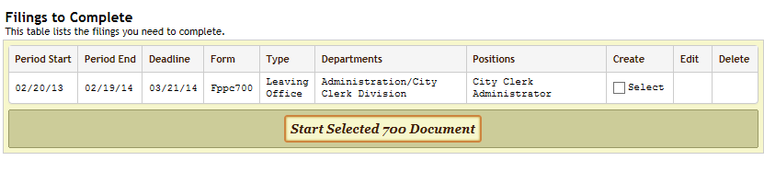

RETURNING FILERS:
- Returning filers who have lost or forgotten their passwords may use the "Lost Your Password" link at the Filing Portal to receive a new password via e-mail. After receiving your password and logging into your account you may create your own familiar password.
- Late filing fees may apply if form is not submitted by the filing deadline.
NEW FILERS:
- New filers, or those who are preparing an electronic filing for the first time, should click the "New User? Request a Password" link at the Filing Portal to register and receive a unique password via e-mail. After receiving your password and logging into your account you may create your own familiar password.
- Late filing fees may apply if form is no submitted by the filing deadline.
If you have general questions or need assistance with filing, please feel free to contact Deputy City Clerk Bonnie Bush via email at bbush@cityofsantacruz.com, by phone at 831-420-5035, or in person at the City Clerk Division/City Manager's Office, 809 Center Street, Room 9. Thank you!
Reference Documents:
- GC §87200
- City of Santa Cruz’s Conflict of Interest Code
- California Fair Political Practice Commission (FPPC) Website
- 2016 Cities and Counties Fact Sheet
- Form 700 Reference Pamphlet – 2015 / 2016
- Form 700 Filing Officer Duties
- Statements of Economic Interests – Form 700

