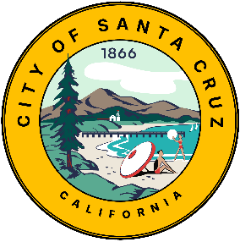

CDBG
Community Development Block Grant
Funds

CBDO Application
2026-2027 Program Year
Applicant Name:

Complete applications must be submitted with the CDBG Application.

Submit the CBDO application using the instructions in the current year’s CDBG Application. This application can be combined as one document or kept as a separate document.

The City of Santa Cruz does not discriminate against persons based on race, color, religion, marital status, sex, national origin, ancestry, age, familial status, disability, or any arbitrary basis. If you need special assistance in order to read and understand the information contained herein, please call the City of Santa Cruz Economic Development Department at 420-5150. The City of Santa Cruz TDD (Telecommunications for the Deaf) number is 420-5733. The Cal-Relay System number is 1-800-735-292.
APPLICATION FOR COMMUNITY BASED DEVELOPMENT ORGANIZATION (CBDO) CERTIFICATION OR RECERTIFICATION
(REQUIRED FOR ALL CBDOS)
Organization: |  |  |  |  |  | Date
Contact Person: |  |  |  | Title:
Address: |  |  |  | Tel. No.
 |  |  |  | Email
Program/Project Name:
Program/Project’s Primary Service Area
Below, briefly describe the activities the Organization undertakes to serve the community, including mission, programs, number of clients served, etc. (250 words max):

This application is to certify/recertify the above-named organization as a Community Based Development Organization (CBDO) for the City of Santa Cruz for a designated program year. Attach any documents referenced in statements below along with information required in Attachments A and B. “Organization” as used in this application refers to the entity that is applying for CBDO status.

For example, if Charter or Articles of Incorporation or used to stabled eligibility below, include as part of this application.

1. Legal Status
 | A. The organization is organized under State or local laws to undertake community development activities as evidenced by its:
 |  |  |  | Charter. |  |  | Articles of Incorporation.
 |  |  |  | Other (specify):
 | B. No part of the organization’s net earnings inure to the benefit of any member, founder, contributor, or individual as evidenced by its:
 |  |  |  | Charter. |  |  | Articles of Incorporation.
 |  |  |  | By-laws. |  |  | Other (specify):

 | C. The organization has a tax-exempt ruling from the Internal Revenue Service under Section 501(c)(3) or (4) of the Internal Revenue Code of 1986, as evidenced by:
 |  |  | A 501(c)(3) OR (4) Certificate from the IRS.
 |  |  | OR
 |  | The organization is classified as a subordinate of a central organization non-profit under Section 905 of the Internal Revenue Code as evidenced by:
 |  |  | A group exemption letter from the IRS that includes the CBDO.
 | D. The organization has among its primary purposes the improvement of the physical, economic or social environment of its geographic area of operation, by addressing one or more critical problems of the area, with particular attention to the needs of persons of low and moderate income as evidenced by a statement in its:
 |  |  | Charter. |  |  |  | Articles of Incorporation.
 |  |  | By-laws. |  |  |  | Resolutions.
 |  |  | (Reference pertinent section of document checked above)
2. Organizational Structure
 | A. The organization maintains at least 51 percent of its governing body’s membership as (1) low-income residents of its geographic area of operation, (2) owners or senior officers of private establishments and other institutions located in and serving its geographic area of operation, or (3) representatives of low-income neighborhood organizations located in its geographic area of operation as evidenced by Attachment A and a statement in its:
 |  |  | By-laws. |  | Charter. |  |  |  | Articles of Incorporation.
 |  |  | (Reference pertinent document and section)
 | * Also complete Attachment A, which identifies all board members and their qualifications.
 | B. The organization is not an organization or instrumentality of the City of Santa Cruz and does not permit more than one-third of the membership of its governing body to be appointed by, or to consist of, elected or other public officials or employees or officials of an ineligible entity (even though such persons may be otherwise qualified as evidenced:
 |  |  | By-laws. |  | Charter. |  |  |  | Articles of Incorporation.
 |  |  | (Reference pertinent document and section)
 | C. Except as noted above, the organization requires the members of its governing body to be nominated and approved by the general membership of the organization or by its permanent governing body, as evidenced by:
 |  |  | By-laws. |  | Charter. |  |  |  | Articles of Incorporation.
 |  |  | (Reference pertinent document and section)

 | D. The organization is free to contract for goods and services from vendors of its own choosing, as evidenced by its:
 |  |  | By-laws. |  | Charter. |  |  |  | Articles of Incorporation.
 |  |  | (Reference pertinent document and section)
3. Neighborhood Revitalization Strategy Area (NRSA)
 | A. Does the CBDO serve part or all of the Lower Ocean-Beach/South of Laurel NRSA?
 |  |  | Yes as a primary service area. |  |  |  | Yes as part of a larger, City-wide service area. |  |  |  | No.
 | Note: The Second Map below also shows the boundaries of the CDBG Low and Moderate Income Target Areas.

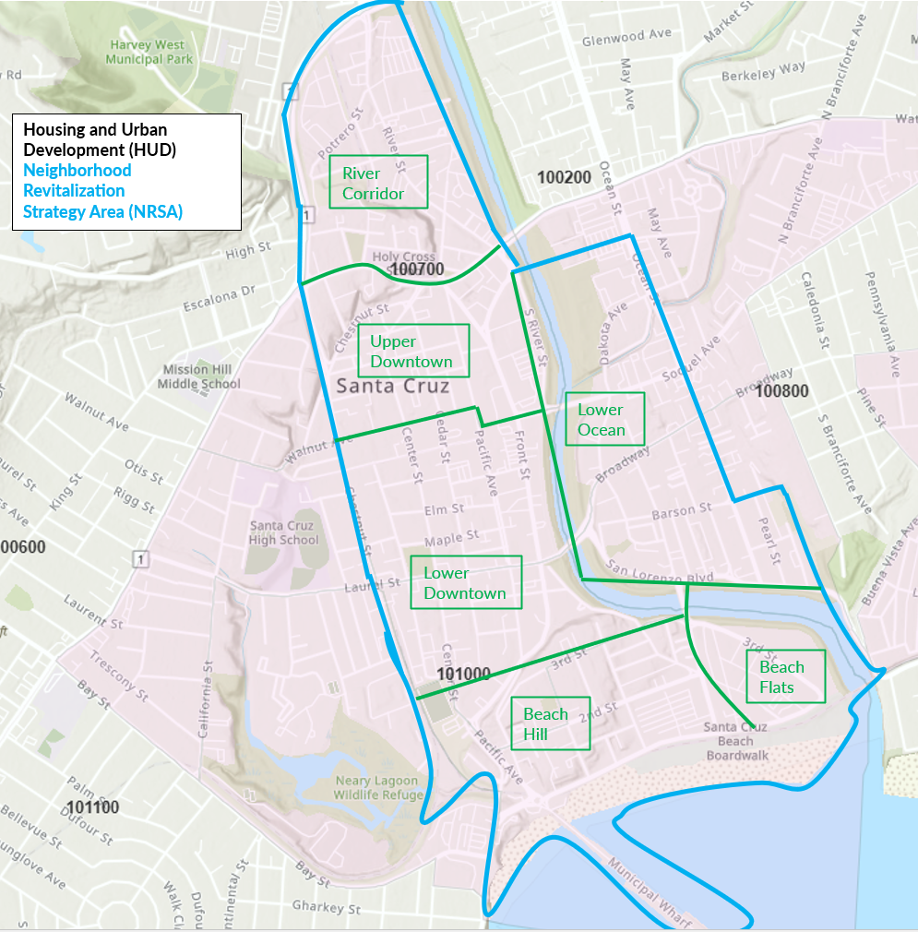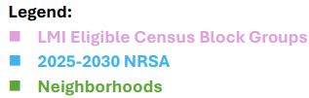

I certify that the Board of Directors of this Organization has reviewed and approved this certification or recertification application for the Organization to be designated as a CBDO. I further certify that the information in this CBDO certification or recertification application is true and correct.

President, Board of Directors |  | Date

CBDO CERTIFICATION APPLICATION - EXHIBIT A
Community Based Development Organization
Governing Board
A Community Based Development Organization (CBDO) is required to maintain at least 51 percent of its governing body’s membership as: (1) low- and moderate-income residents of its geographic area of operation; (2) owners or senior officers of private establishments and other institutions located in and serving its geographic area of operation; or (3) representatives of low- and moderate-income neighborhood organizations located in its geographic area of operation. Please list all Governing Board members and provide Self Certification Forms appropriate to the qualifying category for each Board Member that will be counted as part of the 51 percent.
Name  (List all Board Members) | Place “X” in box if Member qualifies as one of the following for the geographic area of operations of the CBDO. Attach Self Certifying Form A, B, or C for each, as noted below: |  |  | Board Term Expiration Date
Name  (List all Board Members) | Low and Moderate Income Person | Owner or Senior Officer of Establishment or Other Institution Located in Area. | Representative of a Low/Mod -Income Neighborhood Organization | Board Term Expiration Date
Name  (List all Board Members) | FORM A | FORM B | FORM C | Board Term Expiration Date
Total Number of Board Seats:
.
CBDO CERTIFICATION APPLICATION- EXHIBIT A (Continued)
SELF-CERTIFICATION FORM A
LOW- AND MODERATE-INCOME REPRESENTATIVE
For City of Santa Cruz CBDO Governing Body Member
The Federal Community Development Block Grant (CDBG) regulations require that to qualify as a Community Based Development Organization (CBDO) the CBDO must maintain at least 51 percent of its governing body’s membership as: (1) low- and moderate-income residents of its geographic area of operation; (2) owners or senior officers of private establishments and other institutions located in and serving its geographic area of operation; or (3) representatives of low- and moderate-income neighborhood organizations located in its geographic area of operation. This form is to be completed by every board member that is a low- and moderate-income resident of the organization’s geographic area of operation.
Each low- and moderate-income board member must indicate the number of persons in his/her household, and indicate whether total annual household income exceeds or falls below the listed figure for appropriate household size by indicating a check mark in the boxes below.
NOTE: “Income” refers to the total of ALL the annual income of ALL household members. Additional expected sources of income must be included in this calculation of annual household income.
2024 CDBG Income Guidelines for the City of Santa Cruz—
(Check the appropriate income box based on your household size and income.)

Total number of persons in your Household | Total Annual Household Income is Above | Total Annual Household Income is At or Below | Annual Household Income Amount*
1 Person |  |  | $101,750
2 Person |  |  | $116,250
3 Person |  |  | $130,750
4 Person |  |  | $145,300
5 Person |  |  | $156,950
6 Person |  |  | $168,550
7 Person |  |  | $180,200
8 Person |  |  | $191,800

I certify that the information provided on this form is accurate and complete, and that I am a low- and moderate-income resident of the_(Organization’s name)____________________________ area of operation. I further acknowledge that eligibility for meeting HUD’s 51 % low- and moderate-income board requirement is based upon having a qualifying annual household income level, and that the income level I have indicated in this self-certification may be subject to further verification by the City of Santa Cruz and/or HUD.

CBDO Organization’s Name:
Print Board Member’s Name
Board Member’s Address
Board Member’s Signature |  | Date:

CBDO CERTIFICATION APPLICATION- EXHIBIT A (Continued)
SELF-CERTIFICATION FORM B
INSTITUTION/BUSINESS OWNER/SENIOR OFFICER REPRESENTATIVE
For City of Santa Cruz CBDO Governing Body Member
The Federal Community Development Block Grant (CDBG) regulations require that to qualify as a Community Based Development Organization (CBDO) the CBDO must “maintain at least 51 percent of its governing body’s membership as: (1) low- and moderate-income residents of its geographic area of operation; (2) owners or senior officers of private establishments and other institutions located in and serving its geographic area of operation; or (3) representatives of low- and moderate-income neighborhood organizations located in its geographic area of operation. This form is to be completed board members, who qualify as owners or senior officers of private establishments and other institutions, located in and serving the organization’s geographic area of operation should complete this form.
Each owner or senior officer must provide a description of the private establishment or institution, including the type of services provided by such establishment/institution, as well as the targeted area of service.

Business/Institution’s Name:
Business/Institution’s Address:
Is this located in in the CBDO’s Service Area? |  |  | Yes |  | No |  | I don’t know.
Position in Business/Institution held by Board Member:
Briefly describe the goods and/or services that are provided by the Business/Institution:
Describe below the geographic area of operation for the Business/Institution:

I certify that the information provided on this form is accurate. I further acknowledge that the information I have provided in this self-certification form may be subject to further verification by the City of Santa Cruz and/or HUD.

CBDO Organization’s Name:
Print Board Member’s Name
Board Member’s Signature |  | Date:
CBDO CERTIFICATION APPLICATION- EXHIBIT A (Continued)
SELF-CERTIFICATION FORM C
REPRESENTATIVE OF NON-PROFIT OR NEIGHBORHOOD ORGANIZATION
For City of Santa Cruz CBDO Governing Body Member
The Federal Community Development Block Grant (CDBG) regulations require that to qualify as a Community Based Development Organization (CBDO) the CBDO must “maintain at least 51 percent of its governing body’s membership as: (1) low- and moderate-income residents of its geographic area of operation; (2) owners or senior officers of private establishments and other institutions located in and serving its geographic area of operation; or (3) representatives of low- and moderate-income neighborhood organizations located in its geographic area of operation. This form is to be completed by board members, who are representatives of low- and moderate-income neighborhood organizations located in the organization’s geographic area of operation.
Each representative must provide a description of the neighborhood organization, including the type of services provided by such organization, as well as the targeted area of service.

Name of Represented Organization:
Organization’s Address:
Check the box below that best describes the Represented Organization.
 | Neighborhood Association |  |  |  | Non-Profit Civic Organization
 | Non-Profit Service Provider |  |  |  | Other
Briefly describe the services activities of the Represented Organization.
Describe below the geographic area of operation of the Represented Organization.

I certify that the information provided on this form is accurate. I further acknowledge that the information I have provided in this self-certification form may be subject to further verification by the City of Santa Cruz and/or HUD.

CBDO Organization’s Name:
Print Board Member’s Name:
Board Member’s Signature: |  | Date:

CBDO CERTIFICATION APPLICATION- EXHIBIT B
CBDO Application - Attachments

Organization
Below is a list of the documents that may have been referenced in the certification/recertification application. Please mark an “X” in the appropriate box below next to each document that has been referenced in the CBDO application and attach a copy of the document. If the document has already been attached in response to a CDBG Funding Application requirement, mark the box as provided. Only one copy for the complete application package is required. If you have any questions please call the Housing & Community Development Manager at 831-420-5108.
Charter.
Articles of Incorporation.
By-laws.
Resolutions.
Other

